[First Name] [Last Name]
[Title of Position]
National Alliance for Caregiving
Email Address@caregiving.org
1730 Rhode Island NW, Suite 812
Washington DC, 20036
TEL: 315-708-6800 | www.caregiving.org
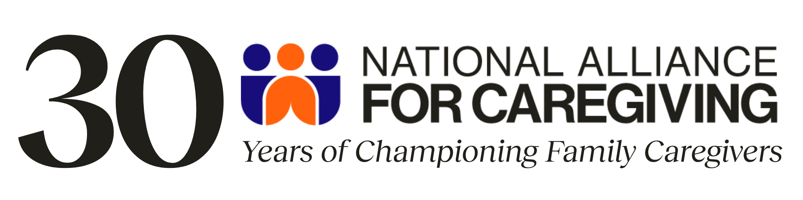
Stay up to date on the most recent caregiving news by signing up for our email list here.
Stay Connected:


